**Orange Juice and the Cowboy Hats - Installation Manual**

### **Part I: Retrieve from GitHub**

1. Download the source code from the latest release from:

<https://github.com/asmithie13/ECE-1140/releases>

1. Unzip the files in a convenient location

### **Part II: Starting the Simulation**

1. Find the file named Start Simulation.bat
   1. Enabling file name extensions will help to ensure you have the right file

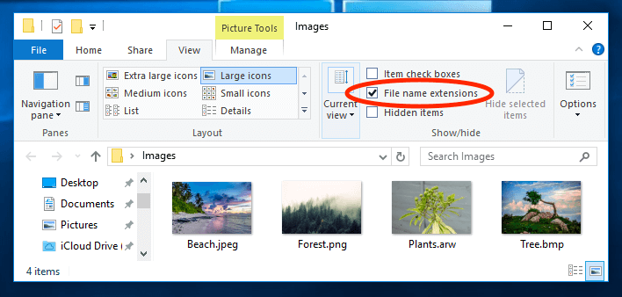

1. Run this file, it will ensure you have the correct versions of required packages.
   1. If you do not have python installed it will throw an error.

Here are some steps to install Python 3.12 on Windows 10:

* + 1. Go to the Microsoft Store app
    2. Search for "Python 3.12"
    3. Select the app published by the Python Software Foundation
    4. Run the installer
    5. Select Add Python.exe to path
    6. Click Install now
    7. If prompted, click Yes to allow the app to change your device
    8. Click Close

**Part III: Using the UI**

Each module can be opened by pressing its button. (Train Model and Controller cannot be opened unless a train is dispatched.

The slider at the can be adjusted to modify the time-speed multiplier

The simulation starts paused, press “start simulation” to start the clock, the time can be paused by pressing this button again.